**OFFICE COLLABORATORY**

**A PROJECT REPORT**

**Submitted By**

**AMAN DHIMAN**

**(University Roll No 2000290140015 )**

**SHWETA RANI**

**(University Roll No.2000290140120)**

**AKASH YADAV**

**(University Roll No. 200029014013)**

**Submitted in partial fulfillment of the**

**Requirements for the Degree of**

**MASTER OF COMPUTER APPLICATIONS**

**Under the Supervision of**

### Mr. Naresh Chandra

### Associate Professor



**Submitted to**

**Department Of Computer Applications**

**KIET Group of Institutions, Ghaziabad**

**Uttar Pradesh-201206**

**(Jan 2022)**

**CERTIFICATE**

Certified that **Aman Dhiman <2000290140015>, Shweta Rani <2000290140120>, Akash Yadav<2000290140013>** have carried out the project work having “**Office collaborator**” for Master of Computer Applications from Dr. A.P.J. Abdul Kalam Technical University (AKTU**)** (formerly UPTU), Technical University, Lucknow under my supervision. The project report embodies original work, and studies are carried out by the student himself / herself and the contents of the project report do not form the basis for the award of any other degree to the candidate or to anybody else from this or any other University/Institution.

**Date:13/01/2022**

**Aman Dhiman (2000290140015)**

**Shweta Rani (2000290140120)**

**Akash Yadav (2000290140013)**

This is to certify that the above statement made by the candidate is correct to the best of my knowledge.

**Date:13/01/2022**

**Mr. Naresh Chandra**

**Associate Professor**

**Department of Computer Applications**

**KIET Group of Institutions, Ghaziabad**

**Signature of Internal Examiner Signature of External Examiner**

**Dr. Ajay Shrivastava**

**Head, Department of Computer Applications**

**KIET Group of Institutions, Ghaziabad**

**ACKNOWLEDGEMENTS**

Success in life is never attained single handedly. My deepest gratitude goes to my thesis supervisor, **Mr. Naresh** **Chandra** for his guidance, help and encouragement throughout my research work. Their enlightening ideas, comments, and suggestions.

Words are not enough to express my gratitude to **Dr. Ajay Kumar Shrivastava**, Professor and Head, Department of Computer Applications, for his insightful comments and administrative help at various occasions.

Fortunately, I have many understanding friends, who have helped me a lot on many critical conditions.

Finally, my sincere thanks go to my family members and all those who have directly and indirectly provided me moral support and other kind of help. Without their support, completion of this work would not have been possible in time. They keep my life filled with enjoyment and happiness.

Aman Dhiman (2000290140015)

Shweta Rani(2000290140120)

Akash Yadav(2000290140013)

.

|  |  |
| --- | --- |
| **Table of Contents** |  |
| **Table of Contents** | **ii** |
| **1. Introduction** | **1** |
| 1.1 Purpose | 1 |
| 1.2 Document Conventions | 1 |
| 1.3 Intended Audience and Reading Suggestions | 1 |
| 1.4 Product Scope | 1 |
|  |  |
| **2. Overall Description** | **2** |
| 2.1 Product Perspective | 2 |
| 2.2 Product Functions | 2 |
| 2.3 User Classes and Characteristics | 2 |
| 2.4 Operating Environment | 2 |
| 2.5 Design and Implementation Constraints | 2 |
| 2.6 User Documentation | 2 |
| 2.7 Assumptions and Dependencies | 2 |
| **3. External Interface Requirements** | **3** |
| 3.1 User Interfaces | 3 |
| 3.2 Hardware Interfaces | 3 |
| 3.3 Software Interfaces | 3 |
| 3.4 Communications Interfaces | 3 |
| **4. System Features**  4.1 Registration Page | **4**  **4** |
| 4.2 Login/Signup Page | 4 |
| 4.3 Admin Section | 4 |
| 4.4 Employee Section  4.5 User Profile 4.6 Logout | 4  4  4 |
| **5. Database Design** | **4** |
| * 1. Use Case Diagram   2. Class Diagram | 5 |
| 5.3 Sequence Diagram | 5 |
| * 1. Activity Diagram   **6.FORM DESIGN**  6.1 Input/output (screenshot) | 5  6 |

**7.CODING** 7

**7.1** Module wise Code 7

**8.TEST CASE 8**

8.1Test case 8

**1.Introduction**

**1.1Purpose**

This document is meant to set forth the features and requirements of office collaborator in a clear and concise way, so as to serve as a guide to the developers on one hand and a software validation document for the perspective client on the other. Under Office Collaboration project our main focus is to build a platform for company wherein we can manage the daily changes of the company ,employee work status and collaborate them into single platform. We will provide two sections of users which will include empolyees and admin. Both sections will be able to manage their own designated roles in the company.

**1.2** **Document Conventions**

1. OC; Office Collaborator
2. SRS: System Requirement Specifications
3. GUI: Graphical User Interface
4. UC: Use Case
5. Approx.: Approximate

## 

## 1.3 Intended Audience and Reading Suggestions

The intended audience of this SRS:

Developers: Project developers can go through this document and understand the requirements presented by the client for the development of the product and start to work on it accordingly. If the developer wants to change, modify or add new requirements/features into the existing system, he/she must first consult this document, update the requirements in an appropriate manner and pass the information correctly to the other phases of the development process.

Marketing Staff: Marketing staff can read this SRS to develop accurate and effective pitches.

Users: Users, mainly students, can refer this document to get a better idea of the functioning of the ELP and determine whether the requirements listed here have been satisfactorily implemented.

Testers: Testers are required to go through the requirements very carefully to design test cases and test the end product to ensure that the requirements presented by the client have been implemented and the software is working efficiently.

## 1.4 Product Scope

OC is one type of platform with the help of the this Company or organization can handle and manage the details of employee.

* Name
* Designations
* Allocated project
* Address
* Current locations ,
* Skills
* Profile photo
* Phone Number
* Reporting manager of the employee
* Date of joining

Number of admin will be multiple who can actually manage all of the above actions. Features of Employees. It will have function to check information regarding

* Attendance
* Total holiday taken
* Salary status
* Project progress
* Next Promotion

The targeted user groups are companies operating various projects on single financial year, each project can be monitored through this individually .

# 2.Overall Description

## 2.1Product Perspective

Office collaboratory is a new project which is not associated to any other already existing educational websites in any way.

## 2.2Product Functions

* OC enables users to perform following functions:

1. Register
2. Login
3. Browse through the website

* It will enable admins to perform:

1. Keep records of user
2. Keep records of employees details
3. Keep records of ongoing and existing projects
4. Add/delete/update data

## 2.3Operating Environment

* The application runs in the latest version of Chrome or Firefox browser on Windows, Linux and Mac.

## 2.4Design and Implementation Constraints

* The user must have individual ID for creating an account
* OC shall be developed using HTML,CSS,BOOTSTRAP.

## 2.5Assumptions and Dependencies

* Database used for OC IS Mysql.
* Operation of the OC depends on the number of concurrent users.
* Each user must have a User ID and password.
* There must be an internet connection.
* There should only be one account per email address.

# External Interface Requirements

## User Interfaces

**Login Screen**: This feature is inbuilt in the software for the verification of authenticated user over the unregistered ones.

**Admin Account**: This enables the user to perform the admin level activities like adding, removing ,updating data of the employee and give the access to the employees to use the platform.

**Employee Account**: This enables the user to view Attendance, total holiday taken, Salary status, project progress, next promotion.

## Hardware Interfaces

## Laptop, Personal Computer, Mobile phones, Tablets

* 1. **Software Interfaces**

##### Front-end: HTML, CSS, BOOTSTRAP

##### Back-end: MySQL

## Communications Interfaces

Employees can communicate with the admin via email provided on the website and hence uses **simple mail transfer protocol** (SMTP).

# System Features

# 4.1 Registration page

# 4.1.1 Description and Priority

# Provides the user with a page to register for the OC

# Priority = 10

# 4.1.2 Stimulus/Response Sequences:

# Stimulus: User clicks on Signup Link.

# Response: Signup Page is displayed

# Stimulus: User enters email address

# Response: The system checks if the email already exists in the database or not. If not then, a verification code sent to user’s email address and the user will be redirected to a page to enter the verification code. Else, and error message pops up stating “This email already exists.”

# Stimulus: User enters verification code

# 

# Response: The system verifies the code, if true then the user is asked to create password.

# Stimulus: User enters password and click on create account button.

# Response: New account is created and user is redirected to the home page.

# 4.1.3 Functional Requirements

# REQ-1: The user should be able to view and click on login link REQ-2: The user should be able to enter and validate the username and Password. REQ-3: There should be only one account per email else and error pop-up should appear.

## 4.2 Login/ Sign up Page

#### **4.2.1Description and priority**

Provides the user with a page to login or register for the OC

* + 1. **Stimulus/Response Sequences**

Stimulus: User clicks on Login Link.

Response: Login Page is displayed

Stimulus: User Enters email and Password

Response: email and Password are validated from the database.

Stimulus: User Clicks on Login Button

Response: Home Page will be displayed, if the login credentials are correct else Error Message will be displayed and the user will be told to enter email and password again.

* + 1. **Functional Requirements**

REQ-1: The user should be able to view and click on login link

REQ-2: The user should be able to enter and validate the username and Password.

REQ-3: There should be only one account per email else and error pop-up should appear.

4.2.4 sequence diagram

**4.3 Admin Section**

**4.3.1 Description and Priority**

Provides the admin with a page to view different options to

Them like attendance of employees, progress of project etc.

Priority = 9

**4.3.2 Stimulus/Response Sequences**

Stimulus: Admin clicks on options given .

Response: Action Page is displayed

Stimulus: Admin clicks on actions required

Response: information /progress report and its description is displayed.

Stimulus: Admin Clicks on change/update Button

Response: Particular action will be performed and result will be displayed With graphs.

**4.3.3 Functional Requirements**

REQ-1: The Admin should be able to view and click on option link.

REQ-2: The Admin should be able to check/update/delete/retrieve particular actions.

REQ-3: The user Admin should be able to view details by clicking on a particular option.

**4.4 Employee Section**

**4.4.1 Description and Priority**

Provides the employees with a page to view their working performance.

Priority = 8

**4.4.2 Stimulus/Response Sequences**

Stimulus: User clicks on employees’ button.

Response: Section are provided through which employees

can check their progress, attendance, bonus etc.

Stimulus: Employee clicks on back button.

Response: The page is reverted back .

4.4.3 Functional Requirements

REQ-1: The employees should be able to view their performance.

**4.5 View User Profile**

4.5.1 Description and Priority Provides the user with a page to view his/her profile

Priority = 9

4.5.2 Stimulus/Response Sequences

Stimulus: User clicks on Settings -> User Profile

Response: User profile is displayed with user details and courses enrolled.

4.5.3 Functional Requirements

REQ-1: The user should be able to click and view his/her profile.

**4.6 Logout Page**

4.6.1 Description and Priority

Provides the user with a logout option.

Priority = 10

**4.6.2 Stimulus/Response Sequences**

Stimulus: User clicks on Logout link

Response: User is logged out and index page is displayed.

**4.6.3 Functional Requirements**

REQ-1: The user should be able to logout from the system.

REQ-2: If no activity is performed within 10 minutes, then the user will be logged out.

### 5-DATABASE DESIGN

**

**5.2 CLASS DIAGRAM**

* 1. **SEQUENCE DIAGRAMTable

     Description automatically generated**
  2. **ACTIVITY DIAGRAM**

**6.FORM DESIGN**

**6.1 INPUT/OUTPUT (Screenshots)**

**6.1.1Admin login**

**6.1.2 ADMIN LOGIN VALIDATION**

**6.1.3 ADD TABLE**

**7.CODING**

**Index.html**

<!doctype html>

<html lang="en">

<head>

    <meta charset="utf-8">

    <meta name="viewport" content="width=device-width, initial-scale=1">

    <link href="https://cdn.jsdelivr.net/npm/bootstrap@5.1.1/dist/css/bootstrap.min.css" rel="stylesheet" integrity="sha384-F3w7mX95PdgyTmZZMECAngseQB83DfGTowi0iMjiWaeVhAn4FJkqJByhZMI3AhiU" crossorigin="anonymous">

    <title>PROJECT</title>

</head>

<body style="background-image:url('img.jpg');background-size: cover;">

    <div class="text-center ">

        <div class="card-header ">

            <ul class="nav nav-tabs card-header-tabs">

                <li class="nav-item">

                    <a class="nav-link active" aria-current="true" href="index.php">Home</a>

                </li>

                <li class="nav-item">

                    <a class="nav-link" href="link.php">Link</a>

                </li>

                <li class="nav-item">

                    <a class="nav-link disabled">About Me</a>

                </li>

            </ul>

        </div> <br> <br> <br>

        <div class="card-body p-3 mb-2 text-white " style="background-color:rgba(134, 247, 69, 0.1)">

            <h2 class="card-title p-3 mb-2 bg-light text-dark">Welcome to Login Panal</h2>

            <p class="card-text bg-light text-dark" style="background-color:black;">Here,You can Login as Admin or Employee </p>

            <a href="login/login.php" class="btn btn-primary">Admin </a>

            <a href="emp-dashboard/emp.php" class="btn btn-primary">Employee</a>

        </div>

    </div>

    <footer>

        Copyright @ 2021-22

    </footer>

    <script src="https://cdn.jsdelivr.net/npm/bootstrap@5.1.1/dist/js/bootstrap.bundle.min.js" integrity="sha384-/bQdsTh/da6pkI1MST/rWKFNjaCP5gBSY4sEBT38Q/9RBh9AH40zEOg7Hlq2THRZ" crossorigin="anonymous"></script>

</body>

</html>

**Code Hierarchy of Coding Implementations :**

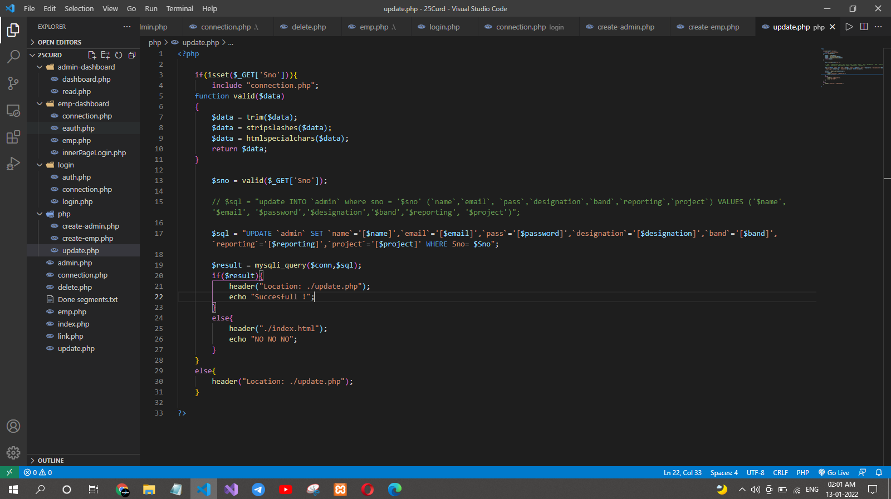

**8.TEST CASE**

A test case is a document, which has a set of test data, preconditions, expected results and postconditions, developed for a particular test scenario in order to verify compliance against a specific requirement.

